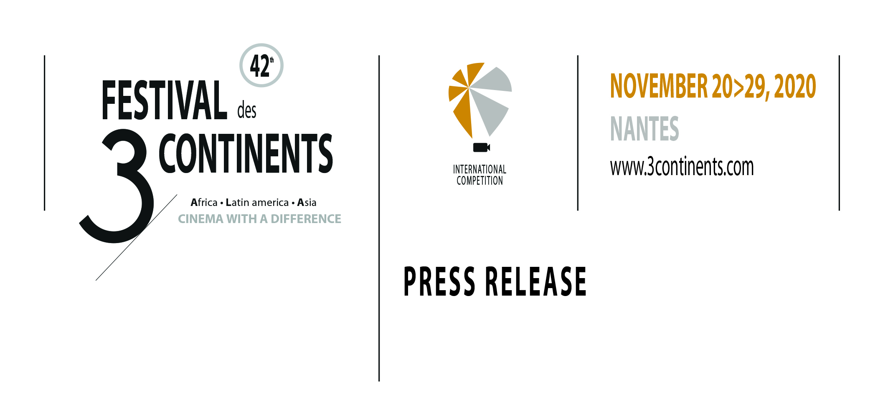
Nantes, September 21, 2020

42nd EDITION OF THE FESTIVAL DES 3 CONTINENTS

The 42nd edition of the Festival des 3 Continents will take place from 20 to 29 November, 2020 in Nantes, France.

- - - - - - -

THE PROGRAMME
The 42nd edition of the Festival des 3 Continents will be offering an expanded official selection of recent films, a tribute to the great Japanese studio Shochiku on the occasion of its centenary, and a programme entitled Tales of Cinema. Films intended for the young audience are also on the programme and the Festival will be organising its 20th Produire au Sud workshop devoted to international coproduction.

. Official Selection
The Festival des 3 Continents will this year be expanding its official selection, which is composed of an international competition and special screenings of feature films and documentaries. Many films, not yet screened in France, and restored heritage films will be presented. By giving visibility to works whose discovery was impeded by the context of the pandemic, we want to show our attachment to their authors and also our support for their producers and distributors.

. 100 Years of Shochiku
On February 11, 1940, the entertainment company Shochiku initiated its activities in the field of cinema production. Just a few years after its creation, the studio confirmed itself as one of the most important in the history of Japan. Although the biggest names, Yasujiro Ozu, Kenji Mizoguchi, Mikio Naruse or Akira Kurosawa, made all or only part of their career there, the exceptional wealth of the Shochiku repertoire turned it into one of the treasures of world cinema. The Festival des 3 Continents could not, with this in mind, fail to celebrate its centenary. (Photo Chasseurs des ténèbres / Hunter in the Dark by Hideo Gosha)

. Tales of Cinema
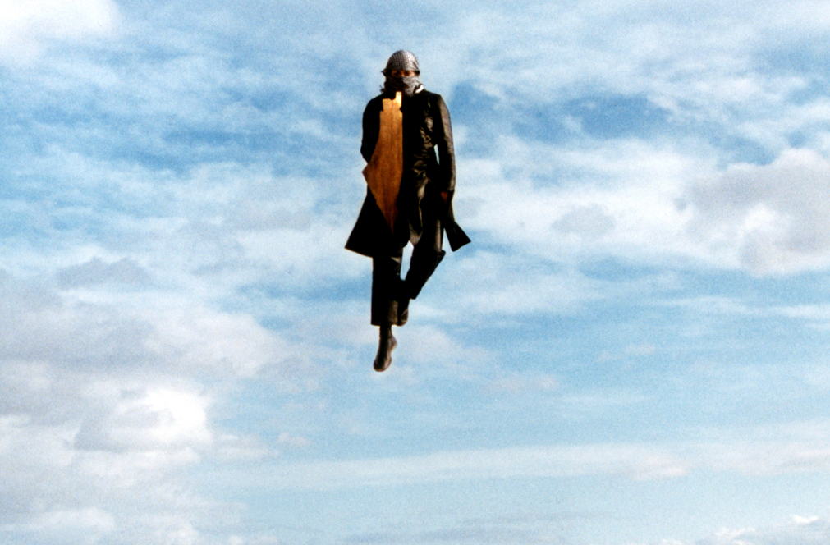
It is less the regular transposition or the adaptation of tales to the screen than the capacity of the cinema to freely reinvent this form that this programme aims to comprehend. To lessen the burdens of the world, these cinema tales oppose their resistance to common sense, to monotony or express in their own way that morals are not static. Among the films, La petite vendeuse de soleil (The Little Girl Who Sold the Sun) by Djibril Diop Mambéty, Petit à petit (Little by Little) by Jean Rouch, Parasite by Bong Joon-ho, Intervention divine (Divine Intervention) by Elia Suleiman, Les Contes de la lune après la pluie (Tales of Moonlight and Rain) by Kenji Mizoguchi. (Photo Intervention divine / Divine Intervention by Elia Suleiman)

. First Steps Towards the 3 Continents
First Steps Towards the 3 Continents offers a selection of films designed for children and their family. Three programmes adapted by level for schoolchildren from the final year of pre-school to different levels of primary school: Premiers pas… dans la forêt by Veronika Fedorova and So-yeon Kim (South Korea/ France/ Russia), Miraï, ma petite soeur (Mirai) by Mamoru Hosoda (Japan), Tito et les Oiseaux (Tito and the Birds) by Gustavo Steinberg, Gabriel Bitar and André Catoto (Brazil). (Photo Tito et les Oiseaux / Tito and the Birds by Gustavo Steinberg, Gabriel Bitar and André Catoto)

. 20th Produire au Sud Workshop
The Festival des 3 Continents will be hosting its 20th Nantes workshop devoted to acquiring tools for international coproduction. The projects of the six two-person teams (producer/filmmaker) selected for the 2020 workshop will benefit from the experience, training and support of a group of experts in the development of the construction of their full-length film. The participants in the 2020 workshop come Azerbaidjan, Brazil, Palestine-Jordan, Thailand, Uganda and Zimbabwe. This edition preceeds the celebration of the 20th anniversary of Produire au Sud in 2021, a labeled year which will bring together the six other countries where it is at present established (India, Israel, Morocco, South Africa, Taiwan and Thailand).
- - - - - - -

The organisation of the Festival is taking shape and adapting to the present health context.

The full programme of the festival will will be revealed on November 5, 2020 during a press conference in Nantes.

- - - - - - -
National and International Press Contacts
Florence Alexandre : + 33 1 48 24 12 91 - florence@anyways.fr
& Vanessa Fröchen : + 33 6 07 98 52 47 - vanessa.frochen@gmail.com

Regional Press Contact
Aurélie Chatelard : + 33 6 19 92 03 31 - communication@3continents.com
- - - - - - -

Every year, at the end of November since 1979, the Festival des 3 Continents has been offering a different view on the cinema and the world,through a unique selection of films, both fiction and documentary, from Africa, Latin America and Asia. The 3 Continents is a non-profit and public utility association, committed to accessibility for the handicapped, sustainable development (REEVENetwork) and support for equality and diversity in the cinema industry (50/50Charter) . www.3continents.com

- - - - - - -

. The 2020 Poster
The visual for the 2020 poster of the Festival is taken from the film Chasseurs des ténèbres (Hunter in the Dark), from 1979, by the Japanese filmmaker Hideo Gosha and produced by the Shochiku studios. The poster was conceived by the graphic design studio LESBEAUXJOURS.

